Tim Vigers
Final Report
May 15, 2020

cgmLens: A web application for viewing continuous glucose monitor data
Introduction
Continuous glucose monitoring (CGM) has become increasingly common in diabetes care over the past 15 years. It allows clinicians to observe free living blood glucose (BG) patterns over multiple days, sometimes without the need for any fingerstick BG measurements. CGMs measure sensor glucose (SG) every 5 – 15 minutes and are usually worn for 7 – 14 days at a time. This provides clinicians and researchers with a huge number of SG observations, approximately 2,000 – 4,000 per CGM wear, which require summary statistics and visualization for effective interpretation. However, despite its increasing use among people with diabetes, there are still no free tools that allow users to examine multiple CGM tracings at once and across multiple CGM brands.
CGM manufacturers use proprietary algorithms to generate summary statistics and visualizations for one patient at a time, and anecdotal reporting suggests that calculations of summary statistics can vary significantly between brands and even across different CGM models within the same brand. A given patient’s CGM model is largely determined by insurance status and personal preference, so clinicians find it difficult to compare CGM results across devices in order to understand sources of variability that may influence CGM outcomes. Also, many clinicians need to look at summary measures that are not included in the proprietary reports, such as using different cutpoints for defining hyper and hypoglycemia in various demographics groups. Currently, clinicians must manually enter summary statistics into a spreadsheet or database and create cohort visualizations themselves, which is a time consuming and error-prone process that many do not have the time or expertise for.
This tool is designed to aggregate multiple CGM data files and present the information in an intuitive way that can be incorporated into clinic flow. For most clinicians, the ability to visually explore the most important aspects of CGM data allows them to make quick decisions, without the need to consult lengthy summary statistic reports spread out across multiple patients. They can use visualization to find patterns in daily BG levels for one or multiple patients, and make comparisons between individual patients and groups. For example, one might compare patients on a new insulin pump to those on a previous model, or search for demographic factors that impact or predict poor glucose control (e.g. one might ask whether teenage boys have higher blood glucose after lunch compared to girls the same age). The information gleaned from our tool can then be used to guide clinical practice and generate hypotheses for research clinicians.
Dataset
The data used to design cgmLens have the following characteristics:
- Approximately 50 files from each of 3 CGM devices: Medtronic Guardian Connect, Dexcom G6, and Abbott Freestyle Libre;
- One file per individual;
- An average of approximately 3,500 glucose measurements per file;
- A participant ID, a column of timestamps, and a column of glucose measurements.

All summary measures presented in the visualization were calculated from the raw glucose measurements, and summary tables are pre-calculated in order to improve performance. Percent time in range (TIR) refers to the percentage of SG values in a given range, which is an increasingly important outcome metric in diabetes care. Ideally, patients would spend 100% of the time in the range 70 – 180 mg/dL, but these targets often need to be adjusted for individuals based on demographic risk, disease history, and other extraclinical factors.
Tasks
cgmLens was designed using Shneiderman’s mantra of: “overview, zoom, filter, details on demand.”¹ It first presents an summary of the data, and then allows the user to drill down and focus on particular participants or groups. Users will be able to:

- Summarize glucose control in a population of interest and for individuals;
- Compare individuals or groups in terms of various summary metrics;
- Identify and discover trends, outliers, and features;
- Enjoy the process of exploring and analyzing CGM data.

Visual Designs
The AGP
The most important element of cgmLens is the aggregate glucose profile (AGP). To generate this figure, all timestamps are first rounded to the nearest 5 minutes. Then, dates are dropped from the timestamps and mean SG is calculated at each 5 minute mark, for the entire cohort and also for each individual. Dropping dates and averaging at each time allows every individual and the cohort mean to be superimposed on the same global frame. This global frame uses the horizontal axis to encode time of day (00:00 to 23:59) and the vertical axis to encode mean sensor glucose. Individuals are all encoded with the same blue hue, and the cohort mean is encoded in orange, to differentiate it from individual lines using a pop out effect. Users will most likely plot at least a dozen individuals at once, which makes it infeasible to encode each individual with a different hue. The AGP can also be displayed in radial form if the user chooses.
The AGP also includes a transparent green box, which highlights a SG range selected by the user. In general, this will be used to help identify patients with poor glucose control, as their lines will be outside of the recommended glucose range (the default is 70 – 180 mg/dL). However, this box can be adjusted to suit other tasks and glucose ranges of interest. Also, because the box could potentially occlude important information or lead to over-plotting, the user has the ability to toggle it on and off.

Figure 1: The AGP with Highlighted TIR and Radial AGP without TIR
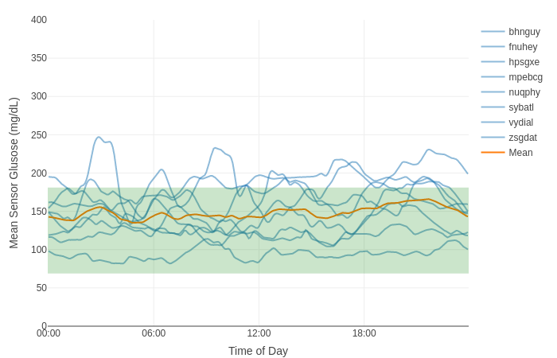
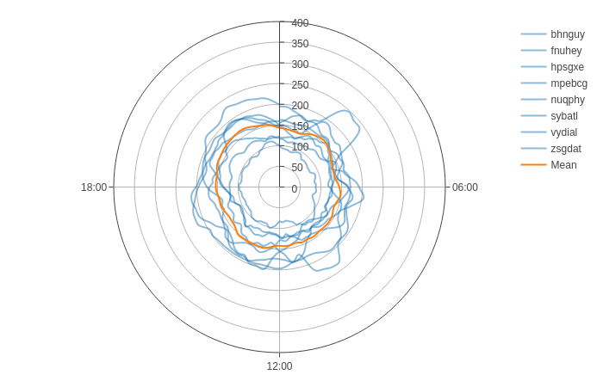

Time in Range Stacked Bar Charts
Below the AGP, the user will see stacked bar charts indicating each individual’s percent time in range. While the AGP allows for a rough estimate of how much time a patient is spending in a desired range, it is important to see TIR in summary as well. Bars are displayed in descending order of percent TIR, to help users rank which patients by level of glucose control. Placing the TIR stacked bars directly beneath the AGP allows the user to indirectly link the two visualizations in their mental map.
Percent time below the selected range is shown at the bottom of the bar in blue, time in selected range is shown in the middle in green, and percent time above range is shown at the top in red. Because most user-selected ranges will be used to indicate good glucose control, percent time in range is shown encoded in green, because green is generally perceived as “good.” Time above and below range currently follow a hot/cold encoding, although this requires further testing with potential users. Many clinicians are more concerned about hypoglycemia than about high glucose, so it may be useful to flag time below the selected range in red, which tends to pop out and connote “bad” outcomes.

Figure 2: Stacked Time in Range Bar Charts
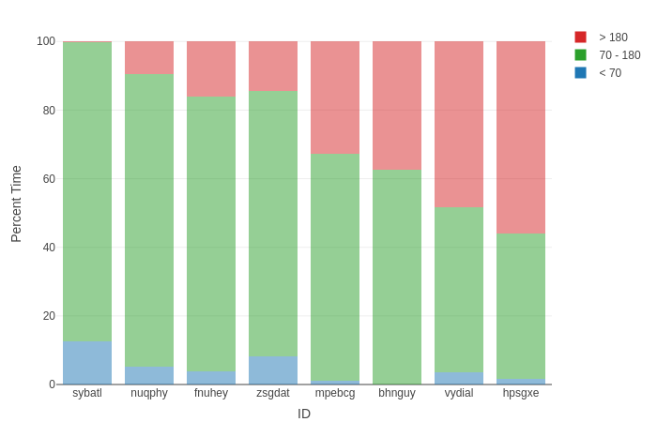

Summary Measures
Below the stacked bar chart are boxplots of percent time in range and other summary measures, such as mean, standard deviation, and coefficient of variation of SG. Boxplots are an effective method of displaying the distribution of quantitative measures, and allow for easy comparison of median, 25th percentile, 75th percentile, minimum, and maximum values. The horizontal axis can be stratified by demographic variables such as ethnicity and gender, in order to facilitate comparisons and help users generate hypotheses about factors that affect CGM outcomes. Alternatively, the user can stratify by “none,” to display the overall distribution of the cohort.
The boxplots of percent time in range follow the same color encoding as the stacked bar charts, to help the user keep a mental map of the data without confusing multiple visualizations of the same metric. Colors for other variables were chosen using the default plotly ColorBrewer palette². Boxplot colors often double encode the stratification variable (e.g. blue for males and pink for females), which further enables comparison between groups. This approach was considered for cgmLens, but it was decided that maintaining consistency across the tool is more important, so that users can easily compare the box plots to stacked bar charts in addition to comparing demographic groups.
Finally, a sortable table complements the boxplots by displaying all summary measures for all participants. This again allows for exploration of the data, as users can rank participants by any variable of interest and see all summary metrics at once. The table does not provide easy comparisons between groups like the previous visualizations, but does enable detailed comparisons of individuals (the “details on demand” of Shneiderman’s approach). In addition to being interactive, some values in the table are additionally encoded using hue. Percent time below range values of more than 10% are colored blue, percent time in range greater than 80% are colored green, and percent time above range greater than 30% are colored red. Encoding table values using hue can help the user discover individuals of interest, and also may allow users to discover patterns related to time in range.
Figures 3 & 4: Summary Measure Boxplots and Table

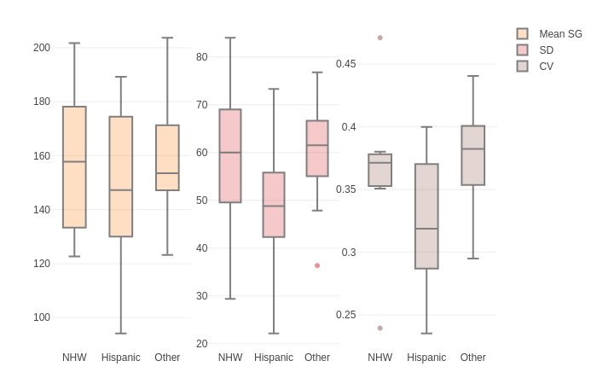
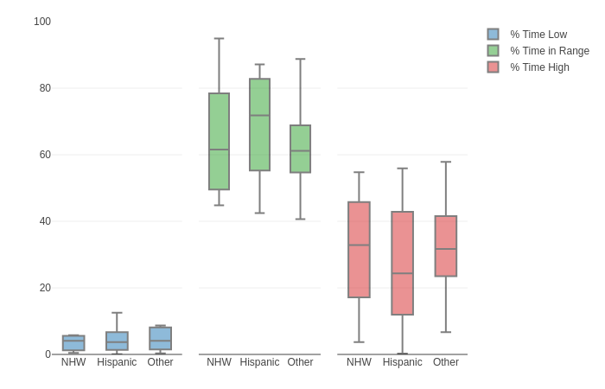

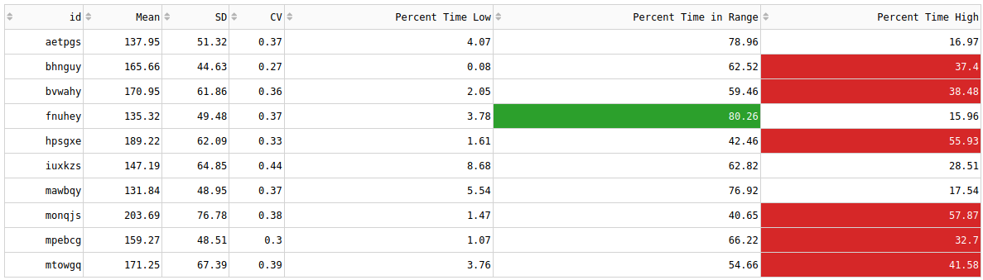

Use Case
As a hypothetical use case for cgmLens, consider a clinician who believes Hispanic females in their clinic tend to have better glucose control than Hispanic males, but want to verify their hypothesis visually. In addition to more time spent in range, they believe that Hispanic females have less hypoglycemia. Also, for the sake of demonstration consider that this clinician is interested in a custom glucose range of 70 – 140 mg/dL
First, they would filter the data by demographics so that cgmLens shows only Hispanic males and females. Next, they would select the appropriate glucose range for their analysis. If desired the user can also apply filters based on data features, such as showing only those participants with mean glucose in selected range. Visualizations across the tool update in response to these filters.
Figure 5: Use Case Filtered AGP

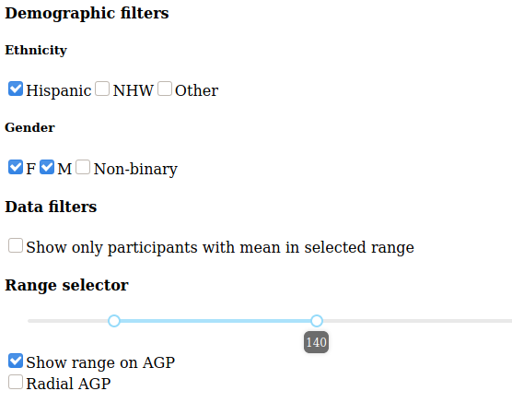
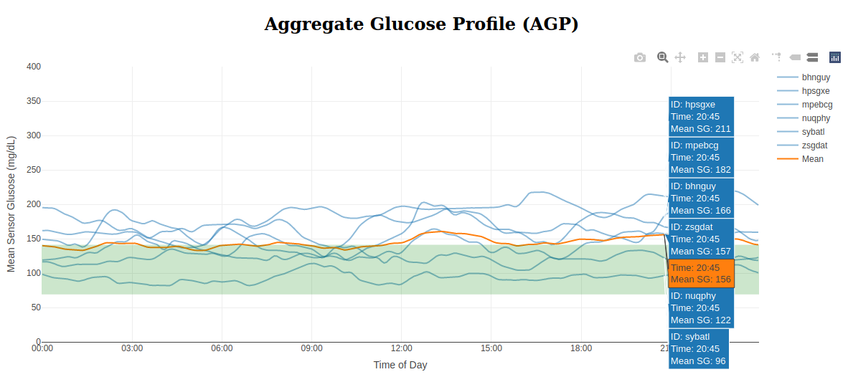

By hovering over the filtered AGP, the clinician can compare individual participants at specific times of day, and compare individuals to the average glucose for Hispanic patients (note that participant IDs would be more informative in a real use case, but had to be deidentified for this report). They can also click participants in the legend to hide or isolate tracings of particular interest. All of these interactions provide an overview of the cohort and may present interesting trends for future exploration, but do not facilitate easy comparisons between groups.
Next, by hovering over the plot the user can examine the stacked bar charts and drill down on percent time in and out of range for each participant. This can help the clinicians determine whether differences between participants are likely to be clinically meaningful or not.

Figure 6: Use Case Filtered Stacked Bars
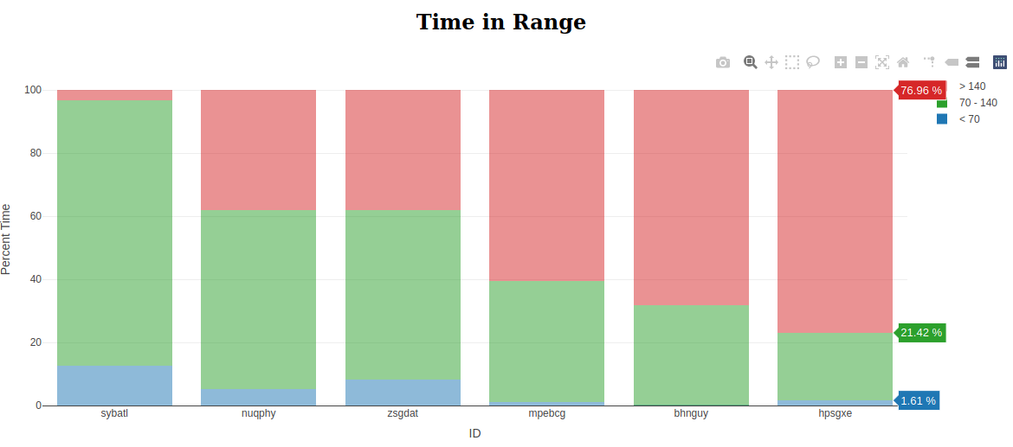

At the end of the analysis, the clinician would use the boxplots to compare summary measures within the Hispanic cohort stratified by male vs. female. In this simulated cohort,

Figure 7: Use Case Filtered Boxplots and Table

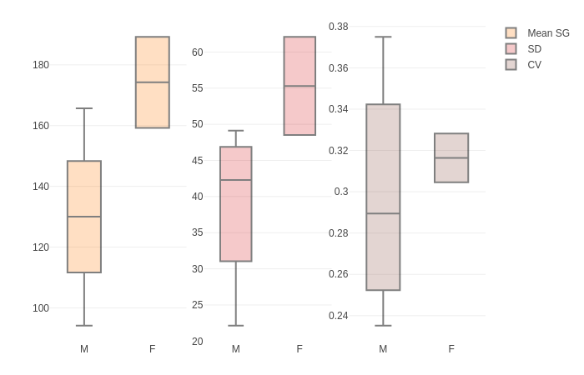
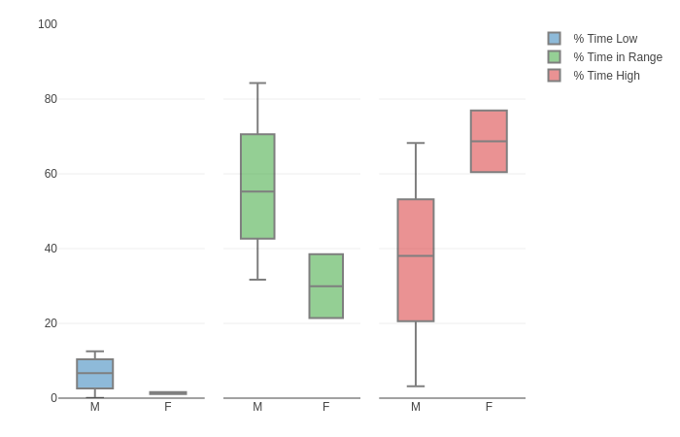
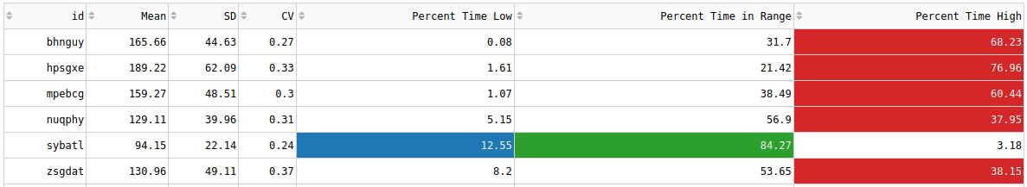
Finally, users can download all visualizations and data for sharing among coworkers and potential research collaborators.
Limitations and Future Directions
There are many limitations to cgmLens, the most important of which is that it has not yet been tested among potential users. Many of the features currently available were included as proof of concept but may require significant refinement after input from users. For example, ethnicity and gender filters were included in this version of the tool as a demonstration of potential use cases, but may not be the most clinically relevant demographic variables. This is also true of the “show only participants with mean in selected range” filtering option, which is simply intended to show that filtering based on data features is possible in addition to filtering on exogenous variables. Also, the cutoffs for highlighting table cells were essentially made up, and do not follow current clinical guidelines. Depending on user feedback, in the future these cutoffs will either be user-adjustable or based on clinical consensus.
Although significant improvements in response time have been implemented, with large datasets the tool can be slow and unresponsive, which has a particularly detrimental effect on task 4 (enjoy using the tool). If possible, all visualization states will be cached so that they are only generated once, as opposed to being re-computed with each interaction. However, scalability is a larger issue with this tool, as the chosen visualizations are subject to over plotting with more than a couple dozen participants.
Perhaps the most obvious limitation of the tool is the lack of innovation in these visualizations. More creative visualizations and interactive connections between plots (for example clicking on a stacked bar chart to turn it into an individual streamgraph) may be added in the future, but for now the focus for this tool is simply the ease of use and facilitating common clinical tasks.

References
1. Shneiderman B. The eyes have it: a task by data type taxonomy for information visualizations. In: Proceedings 1996 IEEE Symposium on Visual Languages. ; 1996:336-343. doi:10.1109/VL.1996.545307
2. Sievert C. Interactive Web-Based Data Visualization with R, Plotly, and Shiny.; 2020.

